Maths Key Skills Stage 5: Skill Check 6

Name: ___________________________________ Date: _______________ Class/Group: _______________________________

A: Place Value, Add and Subtract |  | B: Multiply, Divide and Fractions |  |  | C: Measure and Problem Solving
1. What is the value of the 3 in this number? 2,934,765 | 5:1 | 11. Which is a common factor of 18 and 36? 3 4 5 8 10 |  | 5:8 | 21. Ben was 0.75 metres tall.  Next time he got measured he had grown by of a metre.  2  10  How tall is he now? |  | 5:19
2. Write two hundred and twelve thousand, five hundred in digits. | 5:1 | 12. Give two prime numbers between 10 and 20. |  | 5:9 |  |  | 5:19
3. Round 163,824 to the nearest thousand. | 5:2 | 13. 3,472 ÷ 7 |  | 5:10 | 22. How many grams are there in 6.35 kilograms? |  | 5:20
4. What is the missing number?  2,465 2,365 2,165 | 5:2 | 14. 321.5 x 100 |  | 5:11 |  |  | 5:20
5. What temperature is 12 degrees less than 2 degrees Celsius? | 5:3 | 15. What is 4² ? |  | 5:12 | 23. Calculate the perimeter of this field.  18m  7m  5m  9m |  | 5:21
6. What number is represented by these Roman Numerals? DLXXV | 5:4 | 16.  2  3  2  9  +  =  2  8 |  | 5:13 |  |  | 5:21
7. 10,750 – 2,925 = | 5:5 | 17. Find an equivalent fraction of .  13  5 |  | 5:14 | 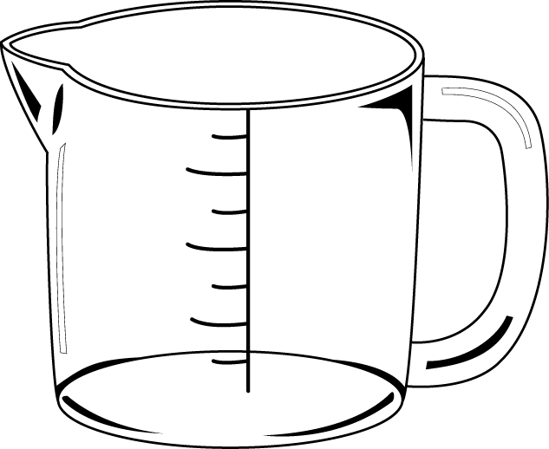  24. Use the glass to estimate the capacity of this jug.  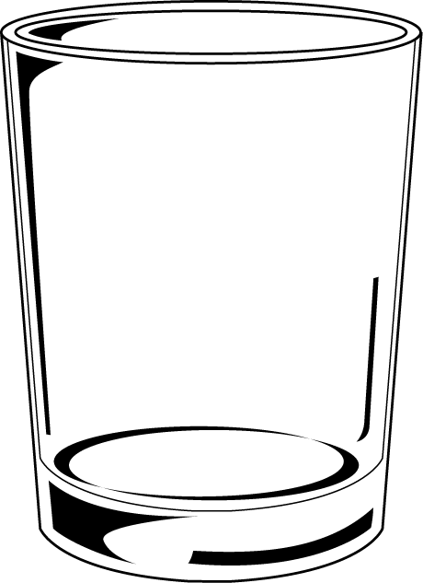  a. 250 ml.  b. 300 ml.  250ml  c. 750 ml. |  | 5:22
8. 6,495 + 8,912 = | 5:5 | 18. Write as a mixed number. |  | 5:15 |  |  | 5:22
9. Complete this sum without written working. 7,800 + 2,500 = | 5:6 | 19.  3  4  x  =  20 |  | 5:16 | 25. Sarah starts watching a film at 10.15am. The film is 145 minutes long. What time does Sarah finish watching the film? |  | 5:23
10. I buy 2 CDs costing £5.90 each. How much change do I get from £15? | 5:7 | 20. Round 4.51 to 1 decimal place. |  | 5:17 |  |  | 5:23
Total (A) |  | Total (B) |  |  | Total (C)
Test Total (A+B+C) |  | R (0-9) | Y (10-19) |  |  | G (20-25)

