Maths Key Skills

Name: ___________________________________ Date: _______________ Class: _______________________________

A: Place Value, Add and Subtract |  | B: Multiply, Divide and Fractions |  |  | C: Measure, Geometry and Statistics
1. What is the value of the 2 in this number? 2,934,765 | 5:1 | 11. Write all of the factors of 18. |  | 5:8 | 21. If 1 kilogram is approximately 2.2 pounds, about how many kilograms are equal to 8.8 pounds? |  | 5:20
2. Put these in order, smallest first:  212,285 32,956 110,000 85,253 | 5:1 | 12. Which of the following are prime numbers? 3 4 7 15 18 |  | 5:9 |  |  | 5:20
3. Round 163,824 to the nearest ten thousand. | 5:2 | 13. 1,016 x 8 |  | 5:10 |   22. Estimate the area of this shape:  1cm |  | 5:21
4. What is the missing number?  117,250 107,250 87,250 | 5:2 | 14. 9.2 ÷ 100 |  | 5:11 |  |  | 5:21
5. Put these in order, smallest first:  -3, 1, -5, 0, 4, -2 | 5:3 | 15. What is 3³ ? |  | 5:12 | 23. Reflect the shape in the mirror line. |  | 5:28
6. What year is represented by these Roman Numerals? MCMXCV | 5:4 | 16. Put these in order, smallest first:  3  5  8  15  7  10  2  4 |  | 5:13 |  |  | 5:28
7. 112,498 – 48,745 = | 5:5 | 17. Find an equivalent fraction of . |  | 5:14 | 24. Customers over a long weekend:  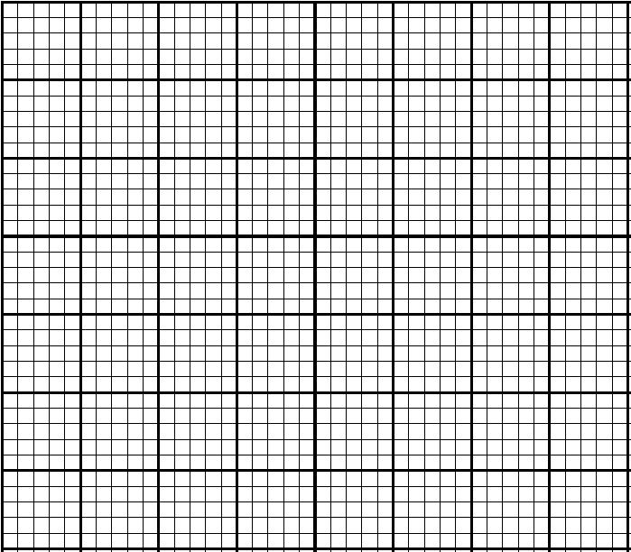  How many  40  30  20  10  0  Fri Sat Sun Mon  No. of visitors  customers  were there  on the  busiest  day?  25. How many customers were there in total over the long weekend? |  | 5:29  5:29
8. 34,857 + 79,384 = | 5:5 | 18. Write the answer as a mixed number.  7  8  11  8  + |  | 5:15 |  |  | 5:29  5:29
9. Complete this sum without written working. 15,200 - 2,050 = | 5:6 | 19.  2  9  x  =  27 |  | 5:16 |  |  | 5:29  5:29
10. The temp. was -4°C. It rose by 9°C, then dropped by 4°C. What is it now? | 5:7 | 20. Write 0.8 as a fraction. |  | 5:17 |  |  | 5:29  5:29
Total (A) |  | Total (B) |  |  | Total (C)
Test Total (A+B+C) |  | R (0-9) | Y (10-19) |  |  | G (20-25)

